**LIST OF COMPANIE’S AI MODEL**

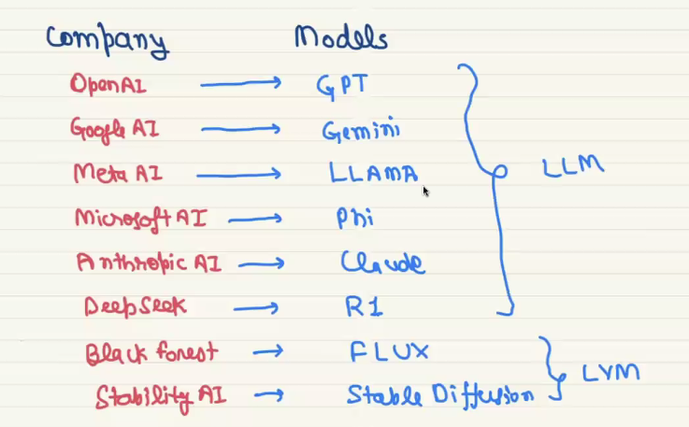

We cannot download the GPT and gemini, and we cant see the algorithm used there, but LLAMA and pi are open source that can be download and we can start build the model with it.

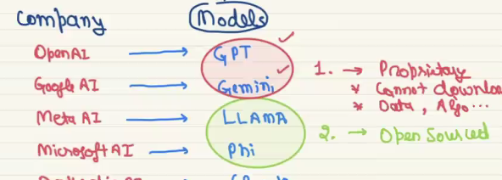

Model.safetesnors is the model that have a lot of parameter in it, in this version of meta model we will have 1 Billion.

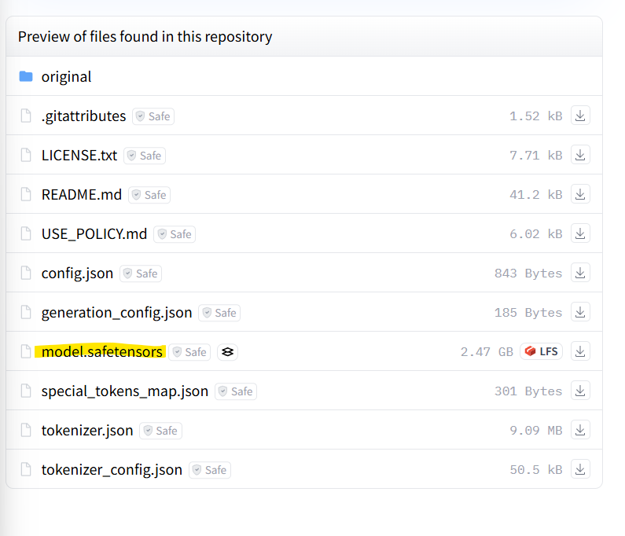

For 70 Billion parameter meta model we will have even very large model like the below one. In below we have a lot of model.safetensor each will have parameter.

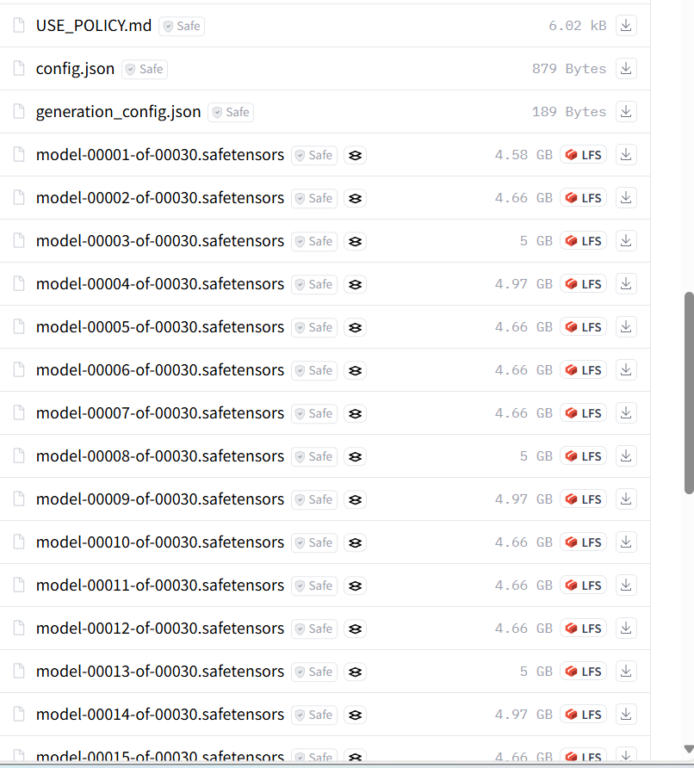

So downloading all these model is impossible on a small RAM computer, But Gemini has API to use it’s AI model that has Key called API key. With that key we can integrate the google’s gemini AI, but with api gemini has limited access we have to pay for unlimited access.

**STEPS TO USE THIS API KEY;**

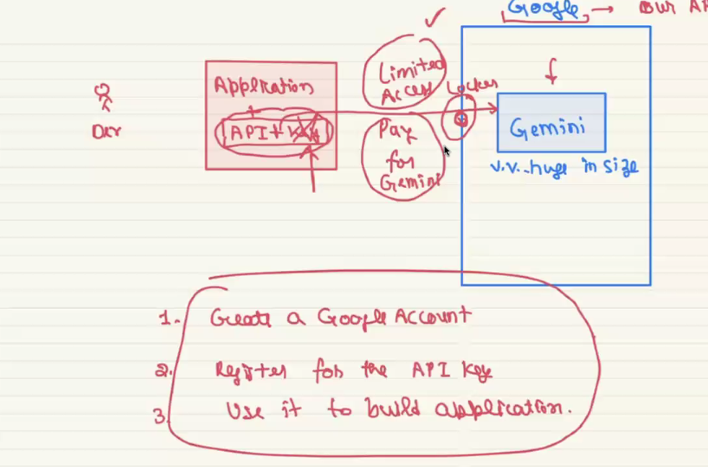

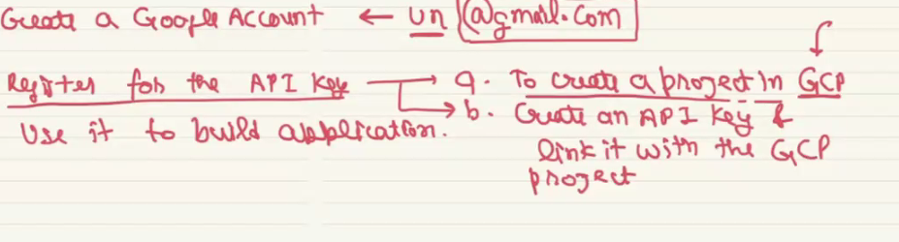

Steps will be in this url

[Generative-AI-Scratch-2-Advance-By-ThatAIGuy/4. GoogleAI Walkthrough/1. Getting Started and Generating API Key/getting_started_with_googleai.ipynb at main · bansalkanav/Generative-AI-Scratch-2-Advance-By-ThatAIGuy (github.com)](https://github.com/bansalkanav/Generative-AI-Scratch-2-Advance-By-ThatAIGuy/blob/main/4.%20GoogleAI%20Walkthrough/1.%20Getting%20Started%20and%20Generating%20API%20Key/getting_started_with_googleai.ipynb)